An-Najah National University Administrator
Lecture 3 commands + using an AI agent inside a Ubuntu VM

1. Introduction
This report documents my work on the Network Administrator task. The task has two parts:
- Try all the commands from Lecture 3 on my device, memorize them, and take screenshots.
- Use an AI agent on my VM and make it write and execute commands by itself.
Everything was done on an Ubuntu 64-bit virtual machine running in VMware Workstation. For each screenshot I explain what was typed, what the output shows, and what I learned.

Quick summary of the commands used
Group | Commands
Getting help | man, man -k, man intro
Navigation | pwd, cd, ls, ls -la, ls -ld
Files & folders | mkdir, cp, cp -r, mv, rm, rm -r, rmdir, echo, cat
Viewing files | more, less, head, tail, wc
Text processing | sort, uniq, cut, grep, paste, tr
Editing & users | vi, passwd
AI agent | sgpt --shell (ShellGPT)

2. Getting Help with man
Before memorizing commands, a network administrator must know how to find help directly on the system. The manual pages (man) are the built-in documentation.

2.1 Manual page of ls
Command: man ls
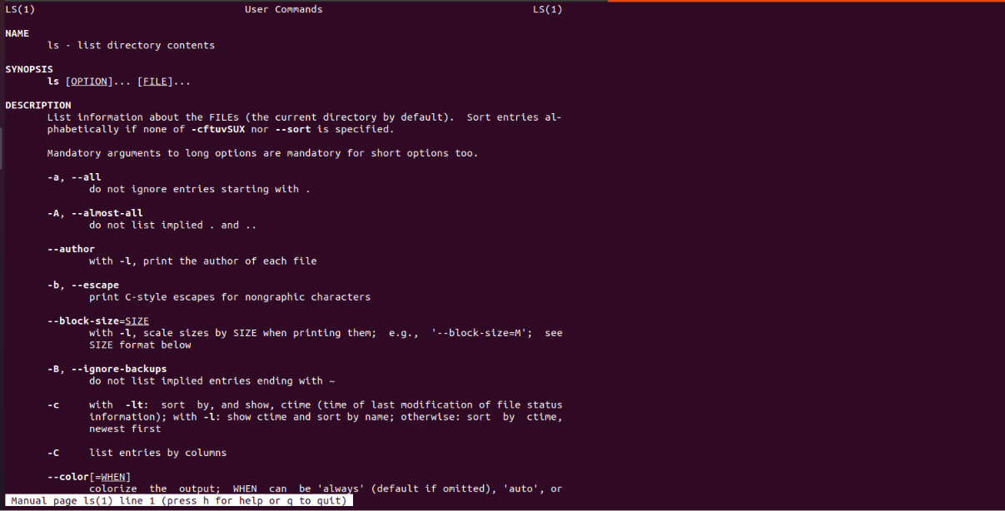
Figure 1: The manual page of the ls command (ls(1))
The page opens with the standard sections: NAME (ls - list directory contents), SYNOPSIS (ls [OPTION]... [FILE]...), and DESCRIPTION, which lists every option. For example, -a shows hidden entries that start with a dot, and -A shows them without . and ... The bar at the bottom says to press h for help or q to quit.

2.2 Searching manuals by keyword
Command: man -k network
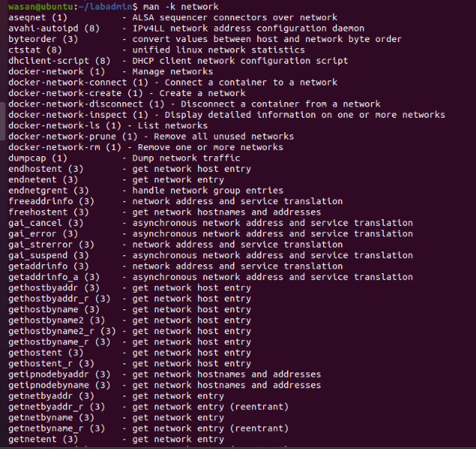
Figure 2: Searching all manual pages for the keyword "network"
The -k option searches the short descriptions of all manual pages. The output is a list of commands with their section number in brackets and a one-line description, such as dumpcap (1) - dump network traffic, or docker-network-ls (1) - list networks. This is very useful when I do not remember the exact command name.
Command: man -k "network interface" | head -10
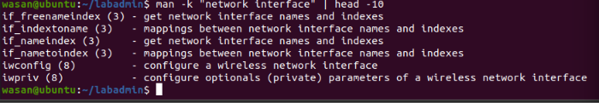
Figure 3: Narrowing the search with a longer phrase and head
Here I used a phrase in quotes to narrow the search, then a pipe (|) to send the result to head -10, which shows only the first lines. Now the results are about network interfaces only, for example iwconfig (configure a wireless network interface).

2.3 The intro page
Command: man intro
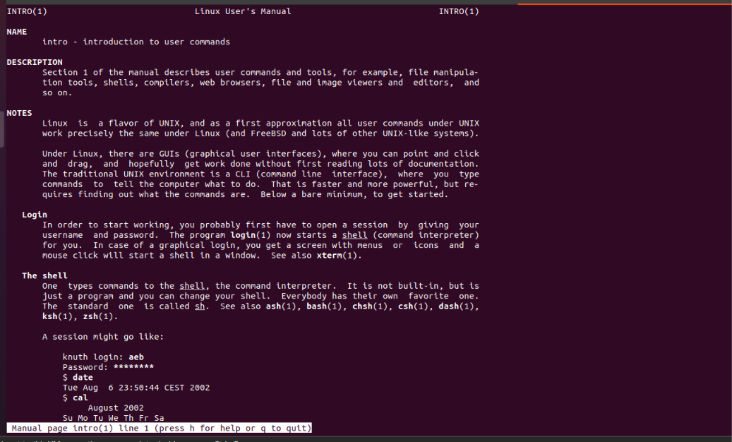
Figure 4: The intro(1) page, an introduction to user commands
This page explains that Linux is a flavour of UNIX and that the traditional environment is the CLI (command line interface), which is faster and more powerful than a GUI but requires knowing the commands. It also explains what a shell is: a program that reads the commands we type. The standard shell is sh, and others include bash, zsh, and dash.
Command | What it does | Example from my lab
man <cmd> | Opens the full manual of one command | man ls
man -k <word> | Searches all manuals for a keyword | man -k network
man intro | Introduction to Linux user commands | man intro

3. Navigating the File System

3.1 First steps: mkdir, cd, pwd, ls -la
Commands: mkdir ~/labadmin, cd ~/labadmin, pwd, ls -la
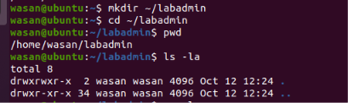
Figure 5: Creating the lab folder and listing it
- mkdir ~/labadmin creates a new folder called labadmin inside my home directory (~).
- cd ~/labadmin moves into it, and pwd confirms the location: /home/wasan/labadmin.
- ls -la shows a long list including hidden files. The folder is empty, so only . (this folder) and .. (parent folder) appear.

3.2 Moving around with cd
Commands: cd /usr/local/bin, cd ~, cd .., cd ~/.., cd ~/labadmin
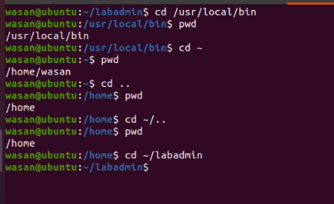
Figure 6: Different ways to change directory
This screenshot tests absolute and relative paths. An absolute path (cd /usr/local/bin) starts from the root /. After cd ~ I went back to /home/wasan. Then cd .. went one level up to /home. Using ~/.. does the same thing, because ~ is /home/wasan and .. is its parent.
Shortcut | Meaning | Result in my lab
/ | Root of the file system | cd /usr/local/bin
~ | My home directory | /home/wasan
. | The current directory | Shown in ls -la
.. | The parent directory | /home/wasan to /home

3.3 Exploring the root directory
Commands: ls /, ls -ld /bin /sbin, ls /usr/bin | head -5
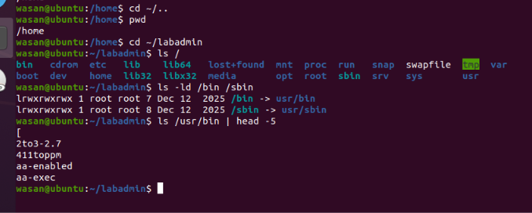
Figure 7: The root directory and symbolic links
ls / shows the main folders of the system such as bin, etc, home, usr, var, and tmp. The command ls -ld shows details of the folders themselves (not their content). The first letter l in lrwxrwxrwx means a symbolic link. So /bin points to usr/bin and /sbin points to usr/sbin, which is how modern Ubuntu is organized. The last command lists a few programs inside /usr/bin, where most commands live.

4. Working with Files and Directories

4.1 Create, copy, and move
Commands: mkdir dir1 dir2, echo "hello" > file1, cp, cp -r, mv, cat, ls
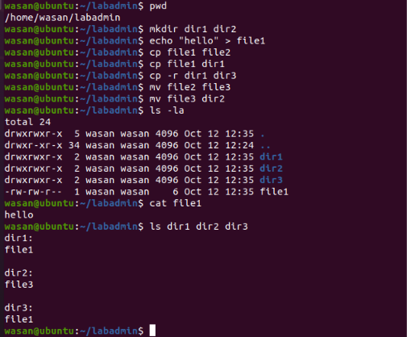
Figure 8: Creating, copying and moving files
Step by step:
- mkdir dir1 dir2 creates two folders at once.
- echo "hello" > file1 writes the word hello into a new file called file1 (the > symbol redirects output into a file).
- cp file1 file2 and cp file1 dir1 copy the file (once under a new name, once into dir1).
- cp -r dir1 dir3 copies a whole folder. The -r option (recursive) is required for directories.
- mv file2 file3 renames file2 to file3, then mv file3 dir2 moves it into dir2.
- cat file1 prints the content (hello), and ls dir1 dir2 dir3 shows what is inside each folder: file1, file3, and file1.

 | cp (copy) | mv (move)
Original file | Stays in place | Disappears from old location
Result | Two copies exist | Only one file exists
Rename? | Yes, by giving a new name | Yes, same folder + new name
Folders | Needs -r | Works without any option
My example | cp file1 file2 | mv file2 file3

4.2 Deleting files and folders
Commands: rm dir1/file1, rmdir dir1, rmdir dir3
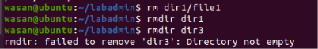
Figure 9: rmdir works only on empty directories
I first deleted the file inside dir1 with rm, then rmdir dir1 succeeded because the folder was now empty. But rmdir dir3 failed with the message "Directory not empty", because dir3 still contained a file.
Commands: rm -r dir3, ls -la
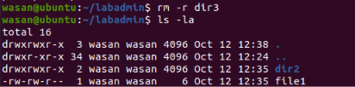
Figure 10: Removing a non-empty folder with rm -r
To remove a folder with content, I used rm -r (recursive). The final ls -la shows that only dir2 and file1 are left. Be careful: rm -r deletes everything inside without asking and there is no recycle bin.
 | rmdir | rm -r
Works on | Empty folders only | Folders with content
Safety | Safe (refuses if not empty) | Dangerous (deletes all)
My result | dir1 deleted, dir3 failed | dir3 deleted

5. Viewing File Content

5.1 more and less
Commands: more /etc/services and less /etc/services
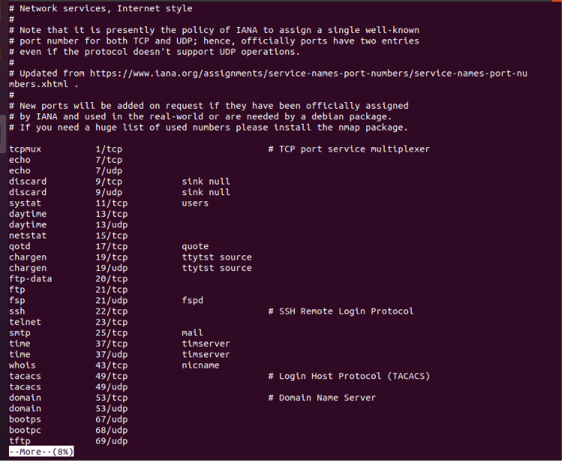
Figure 11: Reading /etc/services with more (8% shown)
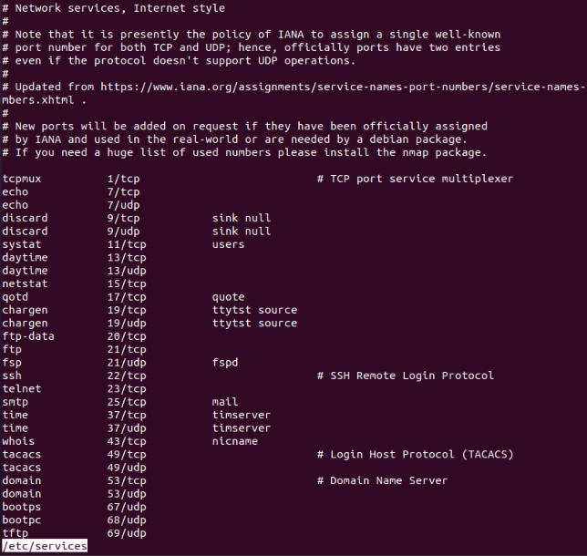
Figure 12: Reading /etc/services with less
The file /etc/services maps service names to port numbers. For a network administrator this is very important: for example ssh is 22/tcp, telnet is 23/tcp, smtp is 25/tcp, domain (DNS) is 53, ftp is 21/tcp, and tftp is 69/udp. The file is long, so I opened it page by page. In the first screenshot, more shows --More--(8%) at the bottom. In the second, less shows a prompt at the bottom line where I can search inside the file.
 | more | less
Scrolling | Mostly forward | Forward and backward
Status line | --More--(8%) | File name or search prompt
Search | Limited | Easy with /word
Quit | q | q

5.2 head, tail, wc, and sort on /etc/passwd
Commands: head -5, tail -5, wc -l, sort, sort -r, sort -t: -n -k3
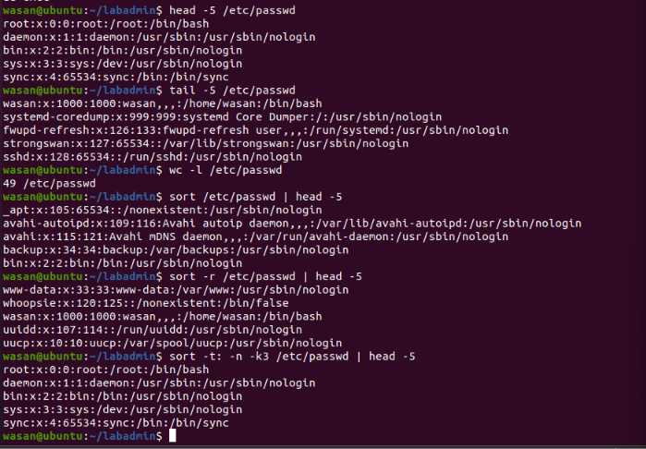
Figure 13: head, tail, wc and sort on /etc/passwd
- head -5 /etc/passwd shows the first 5 lines (root, daemon, bin, sys, sync).
- tail -5 /etc/passwd shows the last 5 lines, including my user wasan.
- wc -l /etc/passwd counts the lines: 49, so the system has 49 accounts.
- sort /etc/passwd | head -5 sorts alphabetically; sort -r sorts in reverse order.
- sort -t: -n -k3 sorts numerically by the 3rd field (the user ID), using : as the separator. That is why root (0) comes first, then daemon (1), bin (2), sys (3), sync (4).
 | head | tail
Shows | First lines of a file | Last lines of a file
Default | 10 lines | 10 lines
Use case | Quick look at the start | Reading newest log entries
My example | head -5 /etc/passwd | tail -5 /etc/passwd

5.3 Understanding the /etc/passwd format
Each line of /etc/passwd has 7 fields separated by colons. Using the line wasan:x:1000:1000:wasan,,,:/home/wasan:/bin/bash as an example:
Field | Name | Value in my example
1 | Username | wasan
2 | Password | x (the real hash is stored in /etc/shadow)
3 | User ID (UID) | 1000 (root is 0)
4 | Group ID (GID) | 1000
5 | Comment / full name | wasan,,,
6 | Home directory | /home/wasan
7 | Login shell | /bin/bash (nologin means no interactive login)

6. Text Processing Tools
Commands: cut, uniq, grep, paste, tr
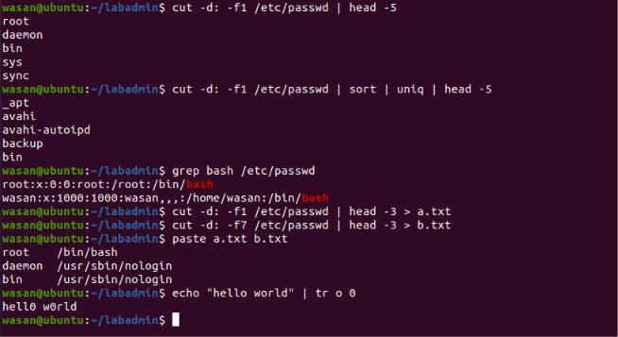
Figure 14: cut, sort | uniq, grep, paste and tr
- cut -d: -f1 /etc/passwd | head -5 takes only the first field (the usernames) using : as the delimiter (-d) and field number 1 (-f1).
- cut ... | sort | uniq | head -5 sorts the usernames and removes duplicates. uniq only removes duplicates that are next to each other, so sort must come first.
- grep bash /etc/passwd prints only the lines that contain the word bash, here the accounts root and wasan, which are the users who can log in with a shell.
- I saved the usernames into a.txt and the shells (field 7) into b.txt with the > symbol, then paste a.txt b.txt joined them side by side as two columns.
- echo "hello world" | tr o 0 replaces every letter o with the digit 0 and prints hell0 w0rld.
Tool | Purpose | Example
cut | Extract columns/fields | cut -d: -f1 /etc/passwd
sort | Sort lines | sort -r file
uniq | Remove adjacent duplicates | sort | uniq
grep | Search for a pattern | grep bash /etc/passwd
paste | Merge files side by side | paste a.txt b.txt
tr | Translate characters | tr o 0

7. User Password and the vi Editor

7.1 Changing a password
Command: passwd
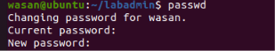
Figure 15: The passwd command asks for the old and new password
The passwd command changes the password of the current user. It first asks for the current password, then for the new one. Nothing is shown while typing, for security. I stopped here without changing it.

7.2 Editing a file with vi
Commands: vi -N test.txt then cat test.txt
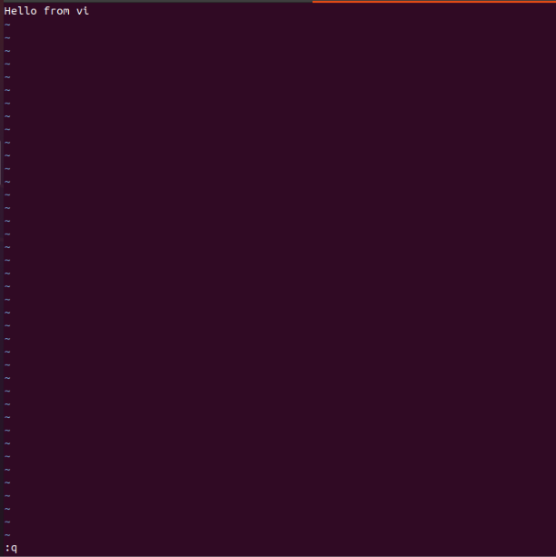
Figure 16: Inside vi, after typing the text and entering :q
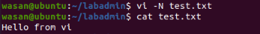
Figure 17: The saved file shows the text I wrote in vi
vi -N opens the file in "nocompatible" mode (a more modern behaviour). Inside vi I pressed i to enter insert mode and typed Hello from vi. The tilde (~) symbols mark empty lines after the end of the file. The command line at the bottom shows :q, the quit command. After exiting, cat test.txt displays Hello from vi, which proves that the file was saved.
Key / command | Meaning in vi
i | Enter insert mode (start typing)
Esc | Go back to command mode
:w | Write (save) the file
:q | Quit
:wq | Save and quit
:q! | Quit without saving

8. Using an AI Agent on the VM
For the second part of the task, I used an AI agent in the terminal. The tool is ShellGPT, started with the command sgpt --shell. I describe what I want in plain English, and the agent writes the Linux command by itself. Then it asks me what to do:
- [E]xecute: run the command now
- [M]odify: edit the command first
- [D]escribe: explain what the command does
- [A]bort: cancel
Note: the screenshots were taken as user wasan4 on a second VM (hostname ubuntu, running in VMware Workstation).

8.1 Experiment 1: Show network interfaces
Prompt: sgpt --shell "Show network interfaces using ip"
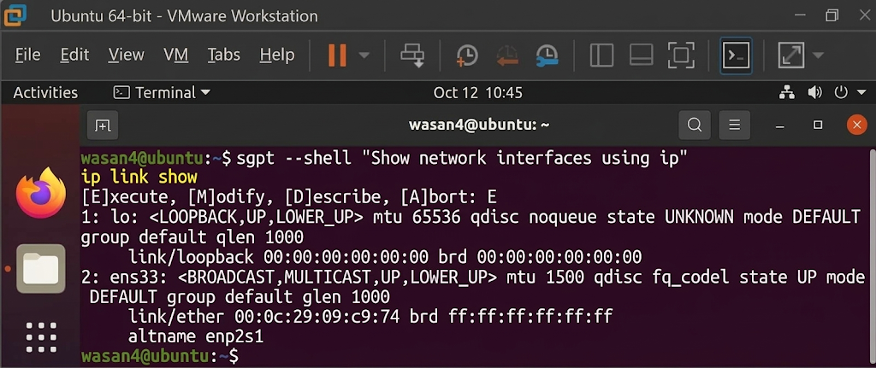
Figure 18: The AI agent generated and ran ip link show
The agent generated ip link show and I chose E to execute it. The output lists two interfaces:
Interface | Type | Details
lo | Loopback | State UNKNOWN, MTU 65536, MAC 00:00:00:00:00:00. A virtual interface used by the machine to talk to itself.
ens33 | Ethernet (VMware NIC) | State UP, MTU 1500, MAC 00:0c:29:09:c9:74, altname enp2s1.

8.2 Experiment 2: Discover live hosts with nmap
Prompt: sgpt --shell "Use nmap to discover live hosts on my local network. First identify my subnet, then generate a ping scan command."
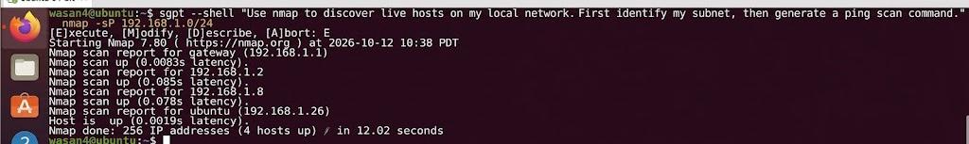
Figure 19: The AI agent generated an nmap ping scan
This was a more creative task. The agent understood the request and produced the command nmap -sP 192.168.1.0/24. The option -sP (ping scan) only checks which hosts are alive, without scanning ports. The scan covered 256 IP addresses and found 4 hosts up in 12.02 seconds:
IP address | Meaning
192.168.1.1 (gateway) | The router, the default gateway of the network
192.168.1.2 | Another device on the network
192.168.1.8 | Another device on the network
192.168.1.26 (ubuntu) | My own VM (latency 0.0019s, the lowest, because it is local)

Important: scanning should only be done on networks I own or have permission to test.

8.3 Manual commands vs. AI agent
 | Typing commands myself | Using the AI agent
Input | Exact command and options | A sentence in plain English
Speed | Fast if I remember the command | Fast even for complex tasks
Learning | Builds memory of the syntax | Can teach through [D]escribe
Risk | My own typing mistakes | Wrong or unsafe command if I execute blindly
Control | Full | I must review before pressing E

9. Conclusion
In this lab I practiced the main Linux commands from Lecture 3: getting help with man, navigating with cd, pwd and ls, managing files with mkdir, cp, mv, rm and rmdir, reading files with more, less, head and tail, processing text with sort, cut, grep, paste, tr and uniq, and editing with vi. I also saw that the system keeps important information in files such as /etc/passwd and /etc/services.
In the second part, the AI agent (ShellGPT) was able to turn English sentences into real commands, such as ip link show and nmap -sP 192.168.1.0/24, and execute them. It is a powerful helper, but a good administrator must understand each command and always check it before running it.

